[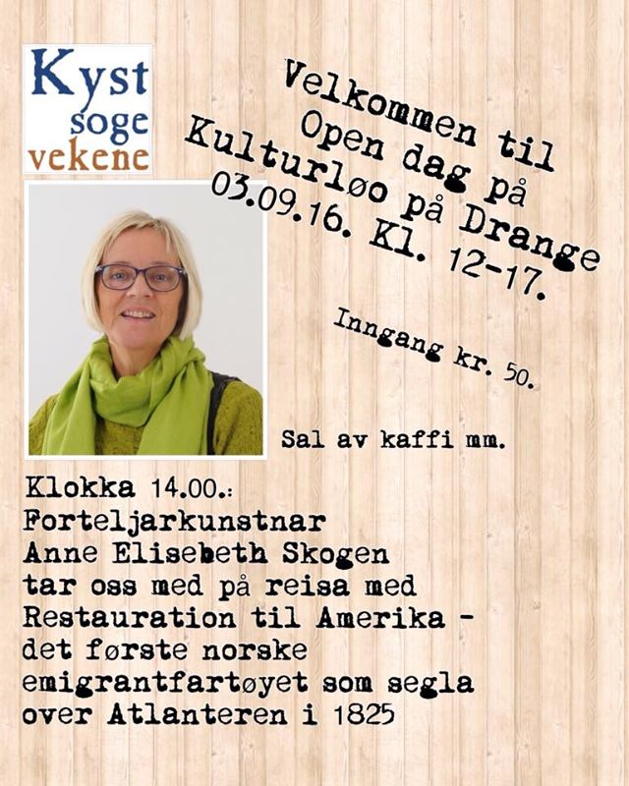](https://www.facebook.com/kulturloo/photos/a.965175000190315.1073741831.785404334834050/1184307144943765/?type=3)